**STRUCTURAL DIAGRAMS**

1. **User Case Diagram:**

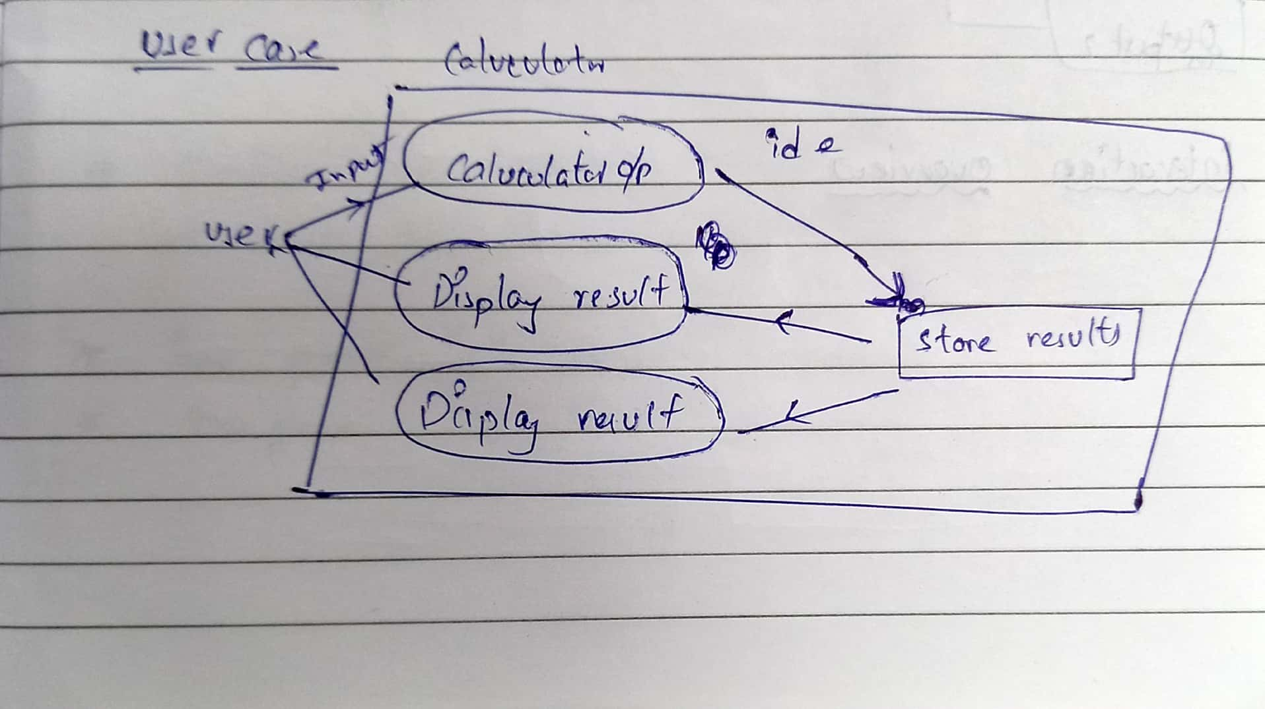

1. **Deployment Diagram**

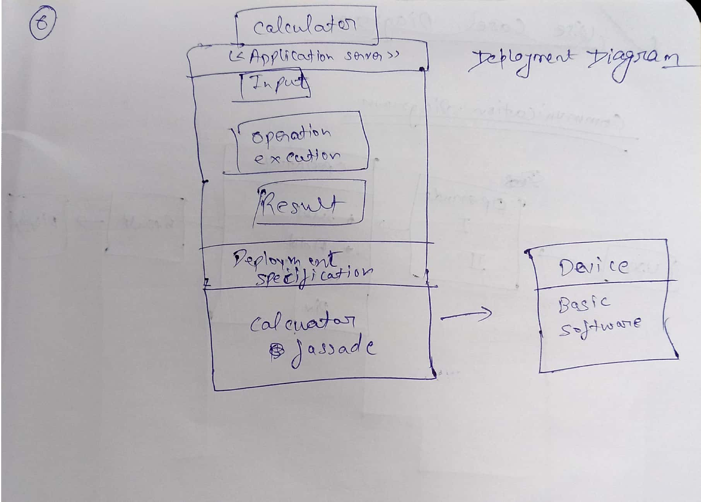

1. **Component Diagram:**

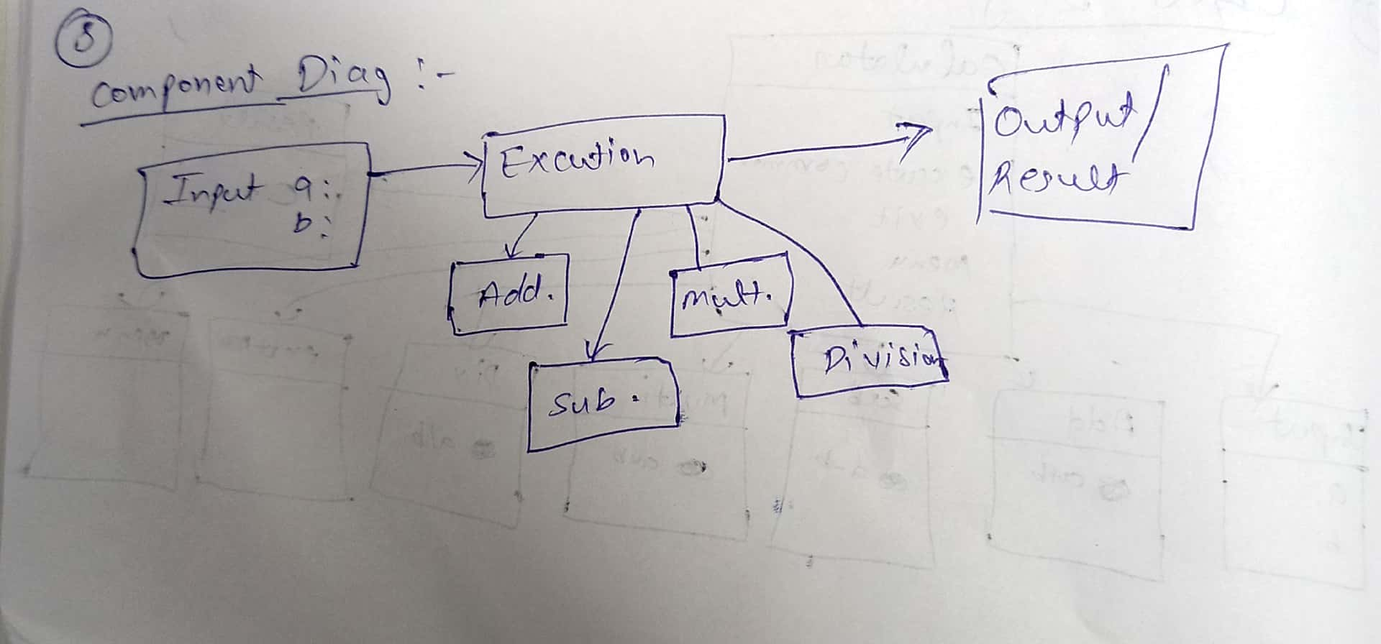

1. **Composite Diagram :**

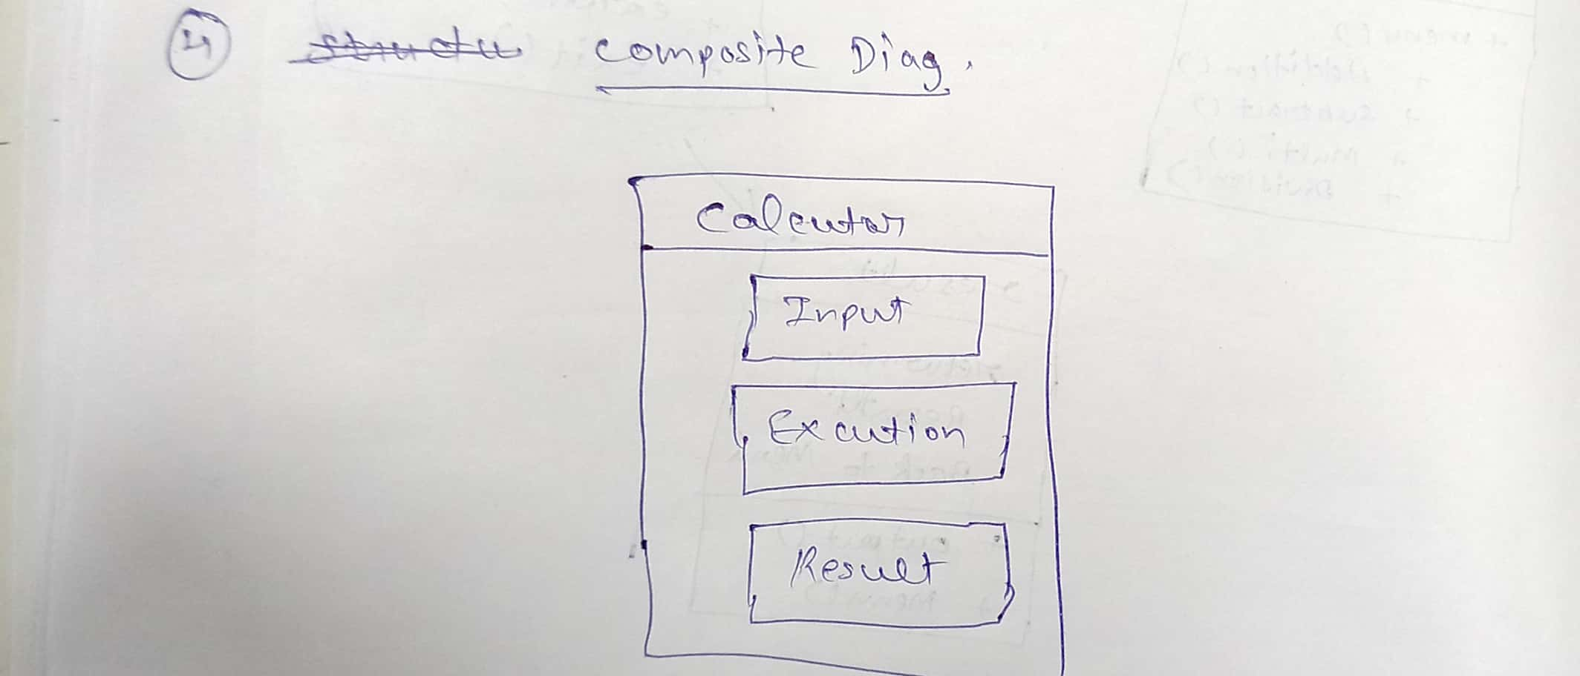

1. **Package Diagram:**

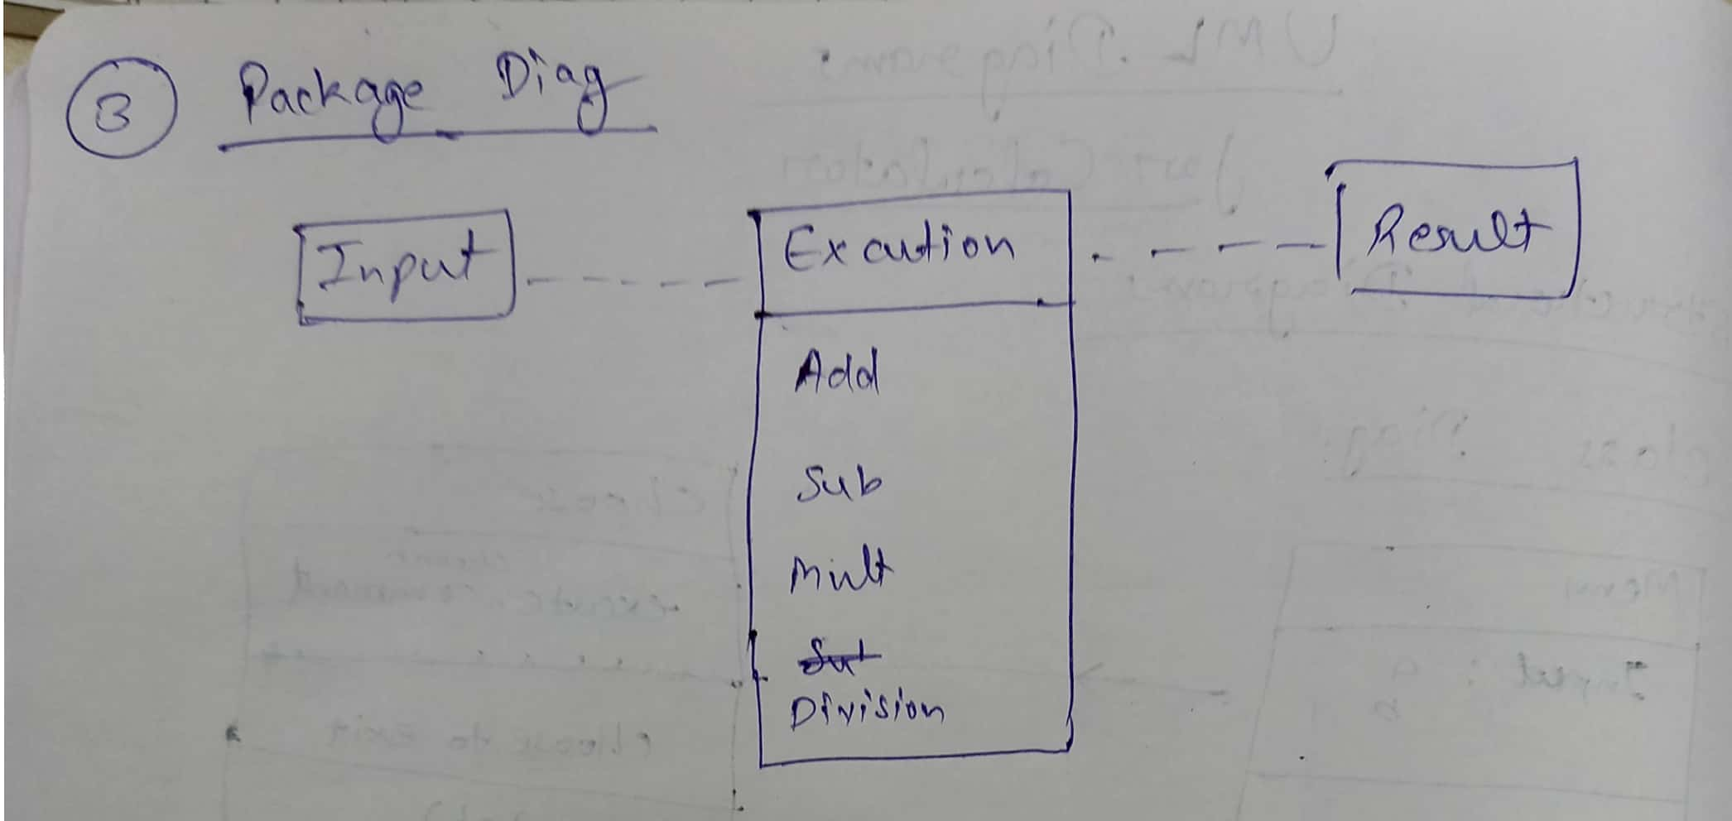

1. **Object Diagram:**

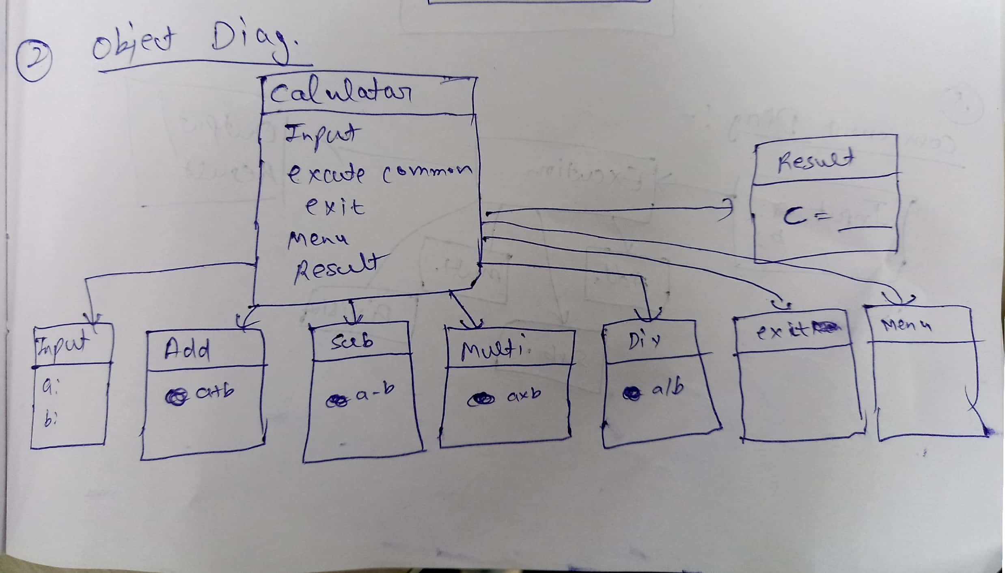

1. **Class Diagram:**

